EMS-PSS High-Level Design Specification

# Core Logic

**Over View:**

The Core Logic is the heart of the project in charge of all main functionality from adding to a database, retrieving from a database and displaying views. There are 6 main classes, an employee class, 4 derived employee classes, employee container class, user class, time class and audit class. These classes are responsible for the information the user enters depending on the type of information the user enters data the core logic will create a Full Time, Part Time, Contract or Seasonal Employee object. The Employee object will be associated with a company and added to the database. The core logic will interact with the database using queries to insert, select and modify tables, it will also interact with the GUI getting data from the user and displaying data to the user it will allow users to login and verify that they are a general or administrative user the core logic will keep track of the user’s permission level.

Some responsibilities include validating all employee object attributes to ensure the data for that type of employee is valid depending on the object-level validation the employee record will be set to “Active”. The core logic will also verify the user when they first login as an administrator or general users by checking the user table in the database. When a user adds an employee the GUI will only display fields valid to the employee specified, the core logic should know what type of employee object to create, the core logic will also know which database table it will try to access depending on the employee type and other attributes. The core logic will Keep track of number of piece and amount of time worked for a seasonal employee, track amount of time worked for all employees with the exception of contract employee through a time card class only a general user may enter time card information.

Tasks include gathering information from the user via the GUI adding the attributes to an employee object and saving the object to a database only fields that specific user can edit will be displayed. Another task is to be able to retrieve data from the database adding the information to an employee object and displaying information to the user. The core logic will Keep track of the type of user logged in, general users will have access to unique views that the administrator user will not and vice versa. Maintain an audit table to keep track of when an employee is being added/modified/inactive, log which user performed the change and when the change was performed, the audit class will act as a logger for any activity performed only an administrative user will be allowed to view audit table information.

**Technology Considerations:**

The technology being used for the core logic will be C#.NET. We decided on C#.NET, because it makes reuse of the employee libraries we wrote in SQI quite easy. This considerably reduces the amount of coding that will need to be done to complete this project.

## Database

**Overview:**

In order the make the EMS-PSS work the database functional area must be able to search the tables and return the data requested. The business-logic functional area will request a search and the database will be searched for relevant data. The first request to the database on each user will be to verify the user. Then it will be to find any data that the user will need to act upon. The database will return all data, and what is shown to the user will depend upon their security level. The database must also be able to store newly created data. The database must also be able to update current database entries.

**Technology Considerations:**

The technology being used for the database of the EMS-PSS will be the Microsoft SQL Server CE built into ASP.NET MVC 3. Data in the database will be controlled by a model in MVC. The data will be requested via a control in a view interacting with a controller that has access to the model that controls the relevant data.

## GUI

**Overview:**

In order the make the EMS-PSS work the GUI functional area must display navigation options, reports, and all other information to the user (certain information being authorization-level dependent) and receive all input from the user, passing it to the business-logic functional area for processing. The GUI functional area depends entirely on the business-logic to receive data from the database and to process all input received by the GUI. The GUI starts by presenting a login page and authenticating the user when they login. The GUI then displays all appropriate information and options for the user’s authorization level. All calculated data and stored data will be displayed to and read from the GUI using the business-logic functional area.

**Technology Considerations:**

The technology being used for the GUI of the EMS-PSS will be ASP.NET MVC 3. The models will interact with the core business logic, the views will display all controls, options, and information to the user and the controllers with handle all data passing between the models and views, as well as transitions between views. We chose ASP.NET MVC 3 because it has a high level of abstraction designed into it between the data access layer, the view layer, and the business rules layer. We also chose MVC 3 because it is C#.NET based which makes calling our pre-written employee DLLs quite easy.

**Screen Mock-Ups:**

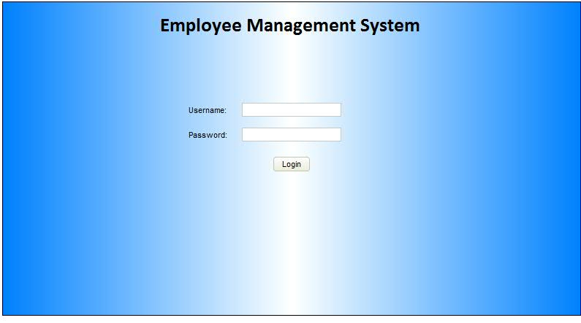

**Initial page**

Purpose:

* First page where users will see, this is where they log in.

Areas of interest:

* Username textbox – area to enter the username
* Password textbox – area to enter the password

**General User**

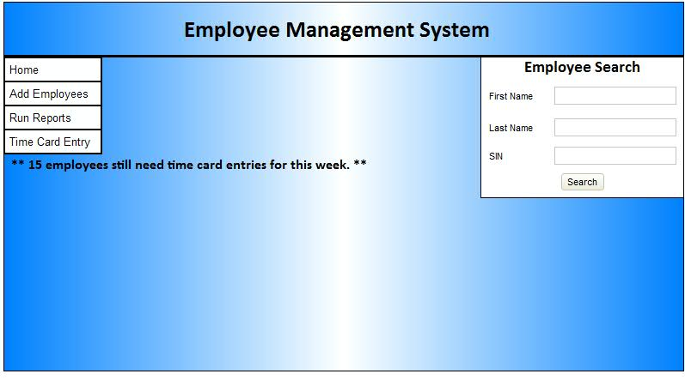

**Home Page**

Purpose:

* First page a general user will see when they log in.

Areas of interest:

* Time Card info div – this shows how many employees need time card entries for that week.

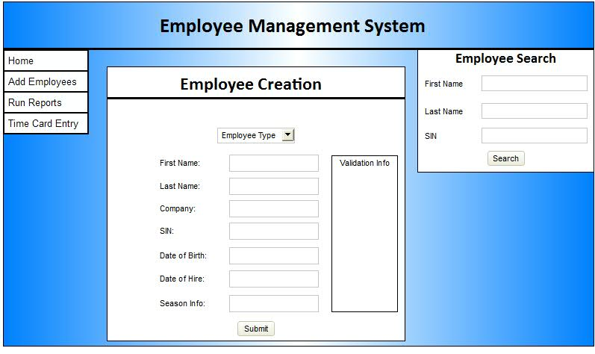

**Add employees page...**

Purpose**:**

This page will present the user with an area to add employees

Areas of interest:

* Radio button or drop down list for selecting employee type
* First name text box – area to enter employee first name
* Last name text box – area to enter employee last name
* Company text box – area to enter the company they are part of
* SIN text box – area to enter their sin number
* Date of birth text box – area to enter their date of birth
* Date of hire text box – area to enter their date of hire
* if seasonal employee radio button or drop down menu selected
  + season information – area to enter the season information
* validation info will appear if something is invalid in the validation info div

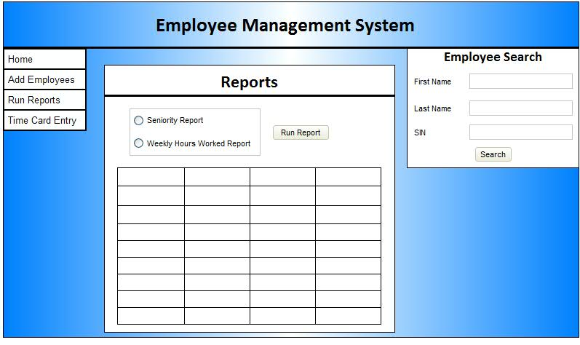

**Run reports page**

Purpose

This page will have 2 options for different reports for general users.

Areas of interest:

* Radio buttons – user will select the type of report here
* Run report button – this will run the selected report
* Report table – this will display the report

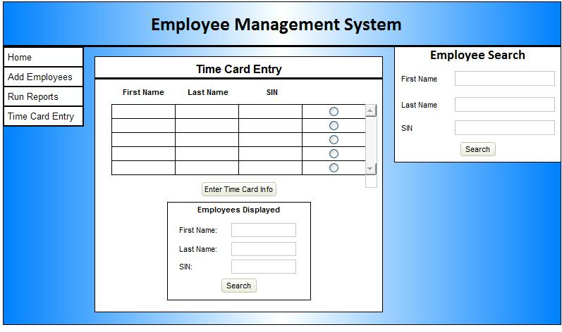

**Time card entry employee selection page**

Purpose:

This is the page where general users will come to select an employee to do time card entries for.

Areas of interest:

* Employee table – this will display all employees unless a search is done below in the employees displayed box
* Employees displayed search box – this will allow the user to filter what is displayed in the above table
* Enter time card info button – this will redirect to the time card entry page for a specific employee which is selected with a radio button in the table

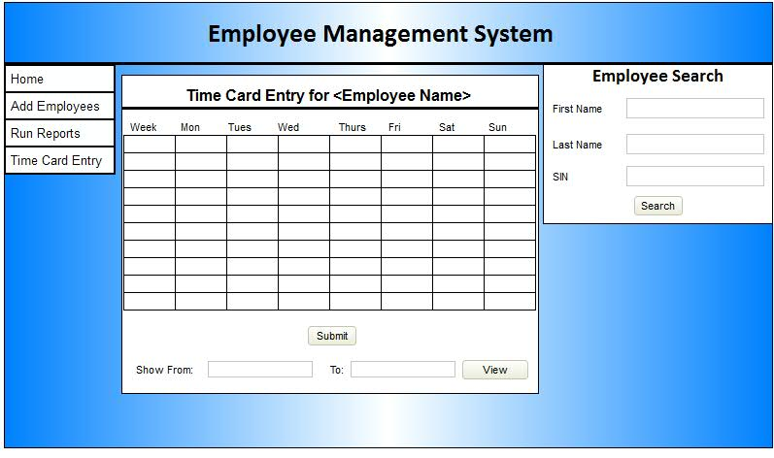

**Time card entry specific employee**

Purpose:

This is where a general user will enter time card information for an employee.

Areas of interest:

* + - Time entry table – this will allow users to enter time card information for a range of weeks
    - Show from – to text boxes – this will allow the user to select the date range for the time card entry displayed in the above table
    - Submit button – this will submit the time card entry data
    - View button – this will change the date range in the above table

**Admin User**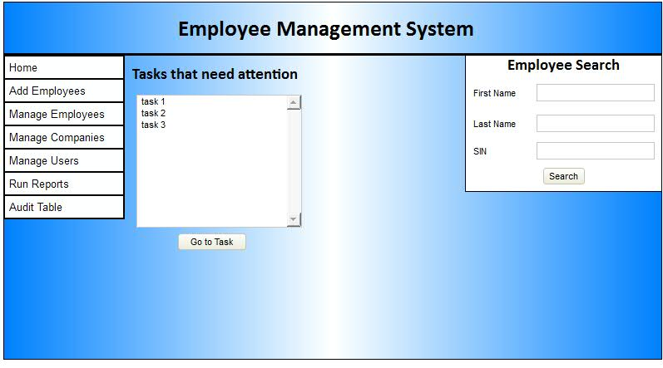

**Home page**

Purpose:

This is the first page an admin will see when they log in. It will display some tasks for them to work on.

Areas of interest:

* admins will be presented a list of tasks that need attention
* go to task button – this will direct the admin to a page where they can complete the task selected in the above list box

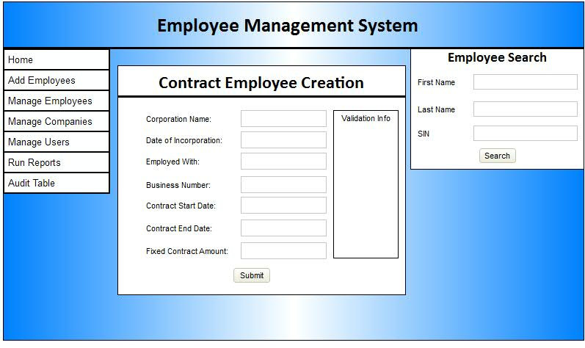

**Create Contract Employees**

Purpose:

This is where admins will come to create contract employees.

Areas of interest:

* Company Name textbox – this will allow the admin to enter the name of the company
* Contract start date textbox – this will allow the admin to enter the start date
* Contract end date textbox – this will allow the admin to enter the end date
* Fixed contract amount textbox - this will allow the admin to enter the contract amount
* Business number – this will allow the admin to enter the business number
* Employed with textbox – this will allow the admin to enter the company they are employed with
* Date of incorporation textbox – this will allow the admin to enter the date of incorporation
* Validation info div – this will display the validation info if something was invalid when submitted with the submit button

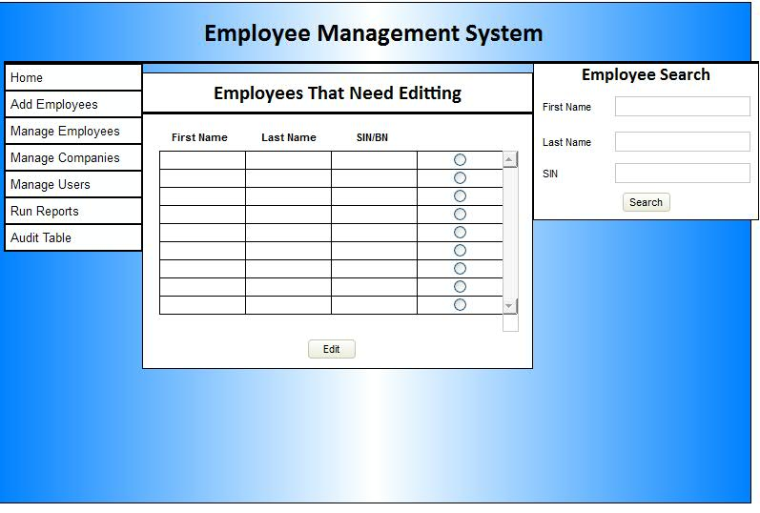

**Manage Employees**

Purpose:

This is where an admin will come to select an employee to edit or complete.

Areas of interest:

* admins will be displayed with a list of employees that need attention
  + this could be..
    - inactive employees
    - invalid employees
* once an employee is clicked..
  + if inactive or invalid
    - admin will be presented with the employees current information and text boxes to update all fields for that employee – this will actually just be the employee edit page
  + once an employee is saved it will let the admin know if the changes were valid and if the employee is now active

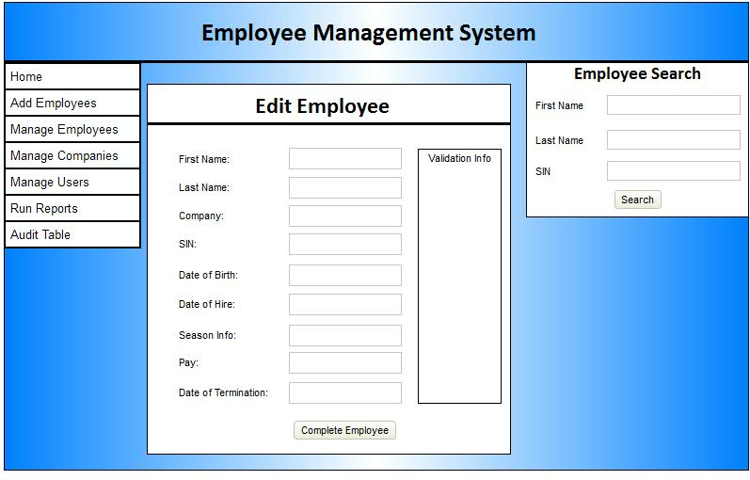

**Edit Employees page...**

Purpose:

This is where an admin will come to edit or complete employees.

Areas of interest:

* First name textbox – this area will allow an admin to edit an employee’s first name
* Last name textbox – this area will allow an admin to edit an employee’s last name
* Company textbox – this area will allow an admin to edit an employee’s company name
* SIN textbox – this area will allow an admin to edit an employee’s sin number
* Date of birth textbox – this area will allow an admin to edit an employee’s date of birth
* Date of hire textbox – this area will allow an admin to edit an employee’s date of hire
* Season info textbox - this area will allow an admin to edit an employee’s season information
* Pay textbox – this area will allow an admin to edit an employee’s pay rate
* Date of termination textbox – this area will allow an admin to edit an employee’s date of termination
* Complete employee button - this area will allow an admin to submit changes to an employee

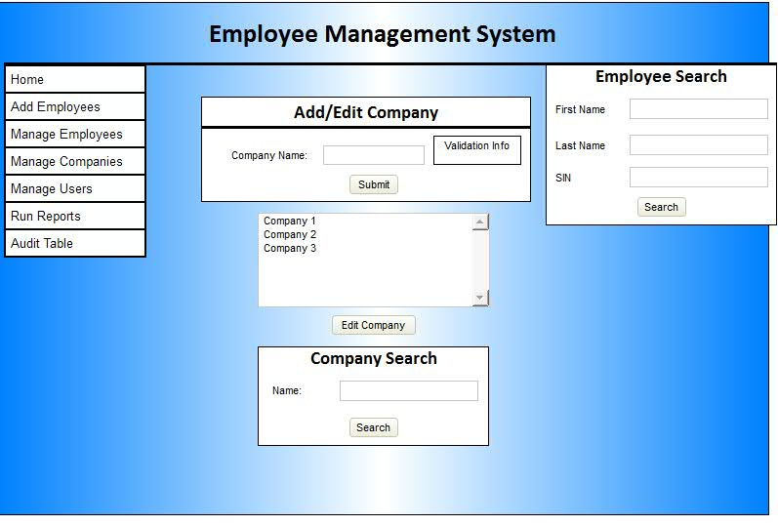

**Manage Companies**

Purpose:

This is where the admin will come to manage companies.

Areas of interest:

* Company name textbox – this area allows admins to add or edit a company name
* Submit button – submits a new company or edits an existing company
* Company list box – this is where an admin can select a company to edit
* Edit company – this button will switch this pageedit company mode from add company mode. The company selected in the list box will be the one edited. Once a company is edited it will go back to adding.
* Company search box
  + Name textbox – this area will allow the admin to enter a name to search for, results will be returned in the above list box.
  + Search button – this will start the company search

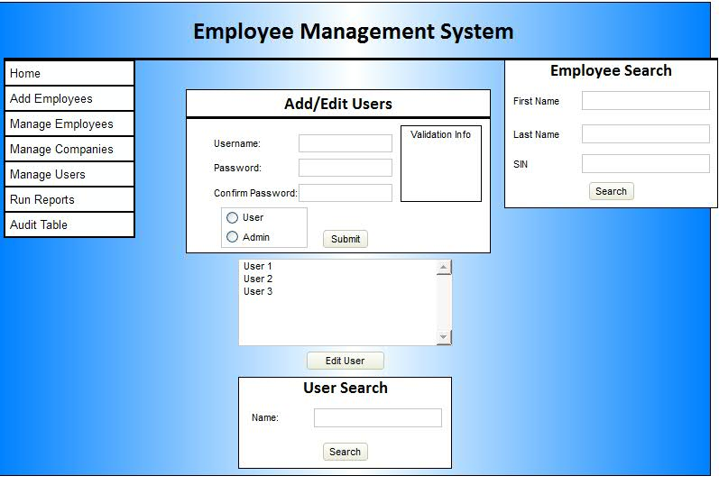

**Manage Users**

**Purpose:**

This is the page where admins will come to add or edit users.

Areas of interest:

* Add/edit users section
  + first name textbox – area to enter the user first name
  + last name textbox – area to enter the user last name
  + password/confirm textbox – area to enter the password for a user
  + security level radio button
  + The below search and list box will work the same as company management.

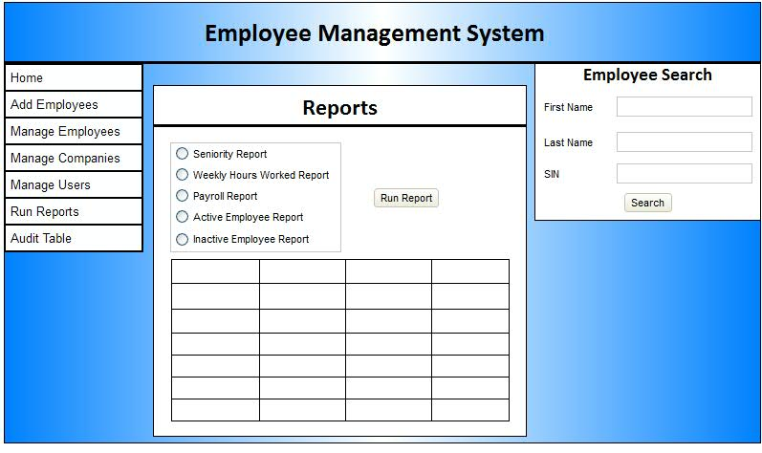

**Run reports**

**Run reports page**

Purpose

This page will allow admins to run reports. This page will have 5 options for different reports.

Areas of interest:

* Radio buttons – user will select the type of report here
* Run report button – this will run the selected report
* Report table – this will display the report

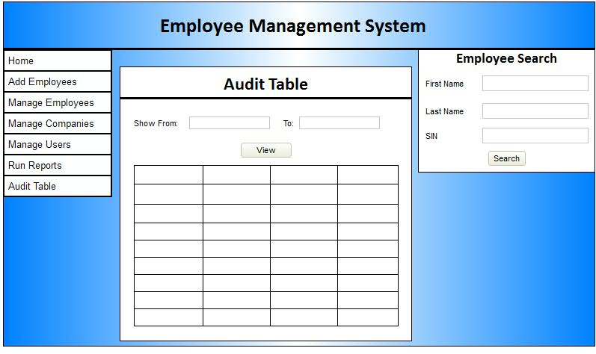

**Audit Table**

Purpose:

The admin will come to this page to view the audit table for the system.

Areas of interest:

# Show from – to boxes – this will all the admin to view system actions within a specific range.

**Elements all pages contain…**

* **Employee Search Bar**
  + Allows any user to wildcard search an employee by...
    - first name
    - last name
    - sin
    - or any combination of all 3
* **Navigation bar**
  + General User
    - Home
    - Add employees
    - Run reports
    - Time card entry
  + Admin
    - Home
    - Add Contract Employee
    - Manage Employees
    - Manage Companies
    - Manage Users
    - Run Reports
    - Audit Table

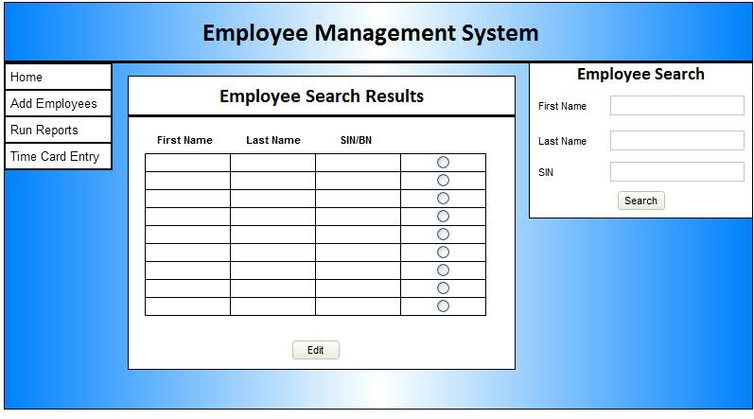

* **Search Results Page...**
  + The user will be presented with a list of clickable search results displaying
    - first name
    - last name
    - sin
    - no contract employees at all
  + Once clicked a General user can see all information about an employee ***except***...
    - date of termination
    - payment information(salary and so on)
  + Admin users can see everything
  + users must also be able to edit employee information by clicking on the employee in the search

# Appendix

Logging In (General User)

|  |
| --- |
| Flow of Activities for scenario General User Logging into the System |
| Main Flow:   1. General User connects to EMS-PMS home page. 2. System verifies the general user information. 3. If General user exists, User logs on. 4. Redirect to General User home page 5. General User Home Page, with tasks to be completed 6. Select an option from home page 7. Update User information 8. Repeat step 5 and 6 9. User logs off |
| Exception Conditions:  3. if system does not verify user exists   1. re-prompt user 2. after 10 attempts lock user out for 15 min |

Adding Employee (General User)

|  |
| --- |
| Flow of Activities for scenario Adding Employee into the System |
| Main Flow:   1. User connects to general user home page. 2. User Selects Add Employee tab. 3. Select Type of employee Seasonal, Full Time and Part Time. 4. Add Employee information. 5. Verify all employee fields are valid. 6. Repeat step 3,4 and 5 7. System adds employee to database. 8. Display if employee was added or not 9. Return to General user Home page |
| Exception Conditions:  3. Cannot enter any information for contract employee   1. Only administrative user can enter contract employee information. 2. If fields are valid 3. Re-prompt user to correct invalid information 4. Display error message |

Logging In (Administrative User)

|  |
| --- |
| Flow of activities for when an administrator is logging in to the EMS-PSS |
| Main Flow:   1. The administrative user enters website 2. The system displays the login screen 3. The administrative user fills in the login page and submits 4. The system validates login fields 5. The system checks the entered login credentials against the user table, authenticating the user logging in as an administrative user 6. The system displays the administrators home screen |
| Exception Conditions:   1. If fields are valid 2. Re-prompt user to correct invalid information 3. Display error message 4. In the event the database is inaccessible the user is informed 5. If the users credentials don’t match any entries in the user database the user will be notified that they entered invalid credentials |

Searching Employee (General User)

|  |
| --- |
| Flow of Activities for scenario General User Searching Employee into the System |
| Main Flow:   1. General User connects to EMS-PMS home page. 2. The general user enter the search area 3. The system displays search area 4. The system validates search fields 5. The system checks the database for employees fitting the search criteria 6. The system displays the search results |
| Exception Conditions:  4. If the user has entered a blank search they are presented with a message of some sort  Implicating that at least one field is required.  6. If the search criteria yields no results, the user is informed   1. If there are no employees in the database, the user is informed 2. In the event the database is inaccessible the user is informed |

Adding Employee (Administrative User)

|  |
| --- |
| Flow of Activities for scenario Administrative User Adding Employee into the System |
| Main Flow:   1. The Admin user selects add employee 2. The system displays adding an employee 3. The admin user selects employee type 4. The admin adds employee details 5. The system validates employee fields 6. The system validates the employee 7. The system adds to the database 8. The system informs user of success |
| Exception Conditions:  5. If the user has entered a blank or invalid field they are presented with a message of some sort implicating that the field is required.   1. If the search employee exists already, the user is informed 2. In the event the database is inaccessible the user is informed |

Employee Search (Administrative User)

|  |
| --- |
| Flow of Activities for scenario Admin User searching for employees in the System |
| Main Flow:   1. The admin enters search information into the search area of the website. 2. The admin presses the search button. 3. The system validates the information entered. 4. The system will query the database. 5. The system will then take the returned results and display them to the admin in a table. |
| Exception Conditions:   1. If the system was unable to connect to the database the admin is informed, asked to try again later and the results are not shown. 2. If there are no employees match the search input the search results page will not show any employees. |

Adding Employee (General User)

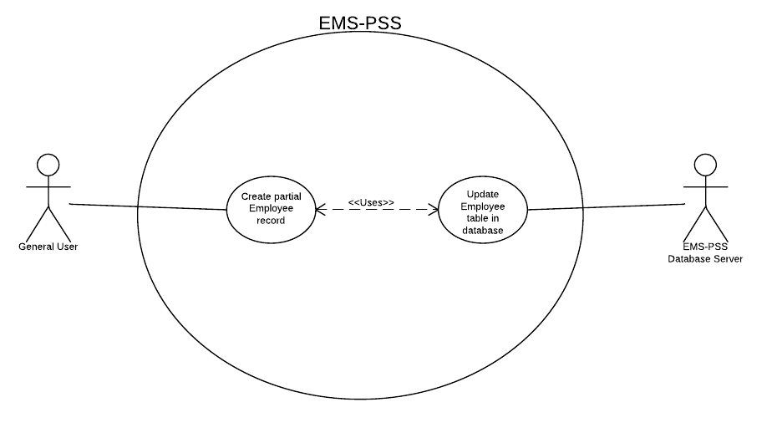

Adding Employee (Administrative User)

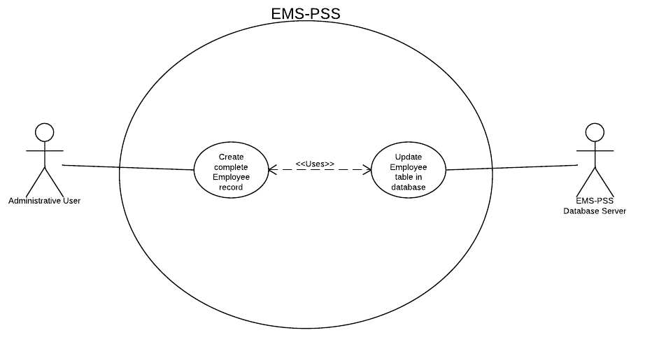

Logging In (General User)

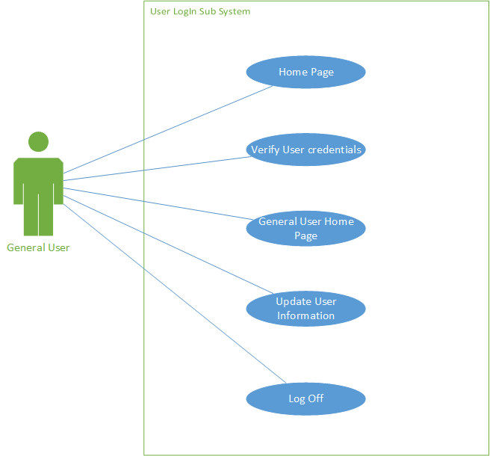

Logging In (Administrative User)

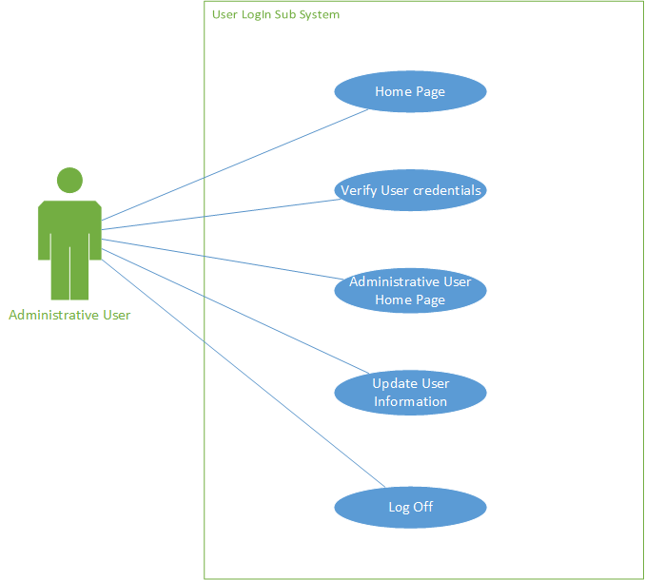

Employee Search (Administrative User)

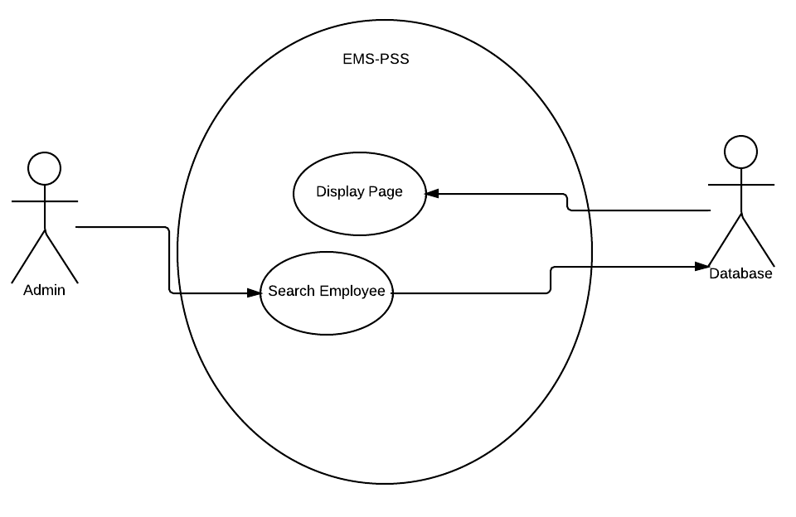

Employee Search (General User)

